Q1. I have a file having CITY column have 100 records. I want the target first letter starts with “A”

And “B” And remaining records as rejected output.

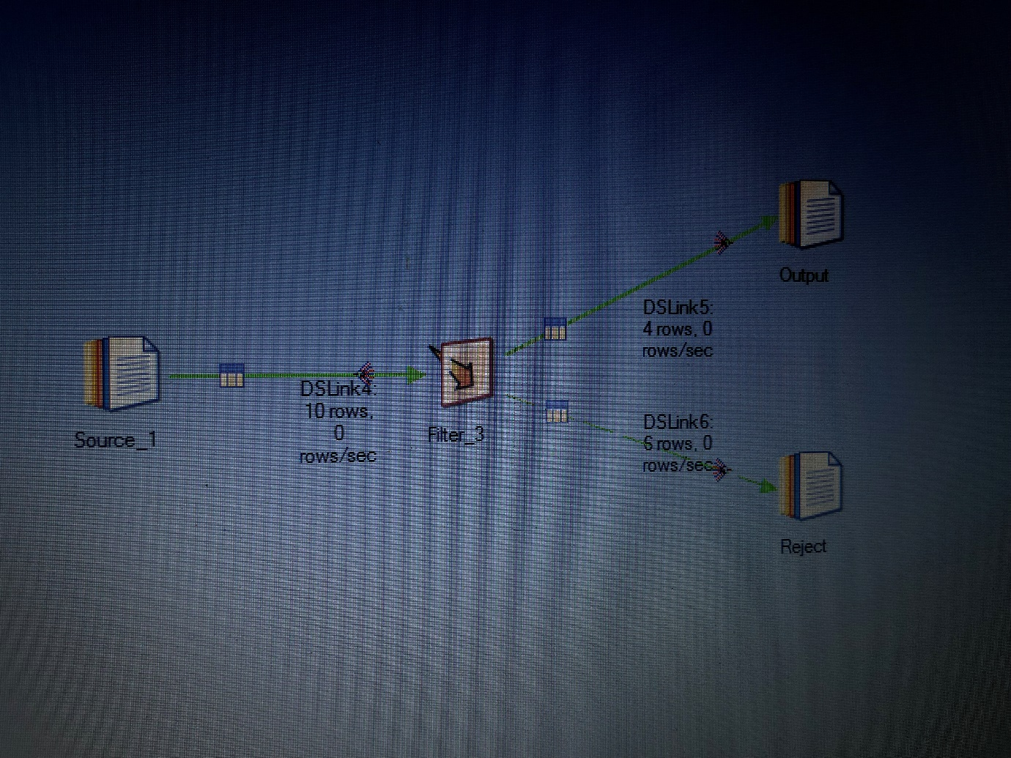

In filter stage :

